Big Mountain Resort is one of the largest ski resorts in Montana and offers skiing and snowboarding facilities. To facilitate distribution of visitors, we have recently installed a new chair lift that has increased our operating cost by more than $1.5M.

Our current ticket price is $81, and we have built a model to determine if this can be increased. Additionally, we will also look at a couple of other ways to increase profit.

**Where do we stand?**

Big Mountain’s current ticket price is at the higher end of the spectrum – at around 81st percentile as compared to other ski resorts around the country. But we are very high up the league table on most dominant features identified by the model. Here is where we stand on these features with respect to our current price:

|  |  |
| --- | --- |
| **Feature** | **Big Mountain Percentile** |
| **Ticket Price** | **81st** |
| Fast Quads | 90th |
| Runs | 93rd |
| Snow Making Area Covered | 97th |
| Vertical Drop | 89th |
| Skiable Terrain | 98th |
| Total Chairs | 95th |
| Longest Run | 94th |
| Trams | 90th |

It is clear from the above table that at Big Mountain Resort we offer multiple premium offering to our customers and that is not being reflected in our ticket price. Our model suggests that ticket price should be **$95.87**. With the expected mean absolute error of $10.39, this suggests there is room for an increase.

**Minimum increase required to cover new chairlift cost**

The new additional chairlift will add a cost of $1,540,000 this season. Considering the usual 350,00 tourists per season and an average of 5 nights spent at the resort per person, the increase in cost per ticket comes out to be**$0.88**. Even with the expected mean absolute error in our model, we can safely increase the ticket prices to cover this.

**Recommendations to improve profit**

In addition to the above observations, we ran multiple scenarios on our model to observe the resulting effect on the ticket price. We determined that the following two scenarios could help reduce cost and/or increase revenue.

**Scenario 1: Closing up to 10 of the least used runs (Strongly Recommended)**

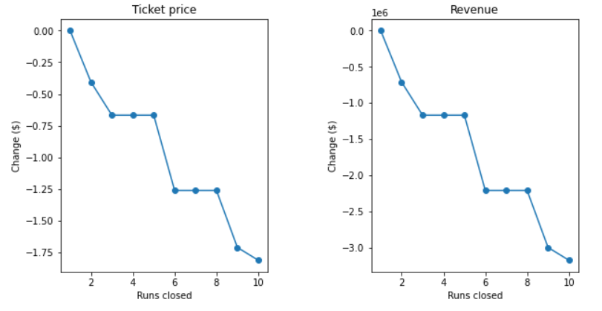

The model says **closing one run makes no difference**. This means we can safely close the least used run and save on our operational costs without affecting the ticket price. The graphs above also suggest that if a future cost cutting need arises, we could close a total of 5 runs with some reduction in revenue.

**Scenario 1: Adding a run, increasing the vertical drop by 150 feet, and installing an additional chair lift (Needs Further Investigation)**

This looks promising as it increases the ticket price by $1.99 the revenue by $3,474,638. However, we would need to further investigate how much operational cost this would add.